Resilience and Resistance:
Immigrant Youth and Families
Edited by
Flavio Bravo and Erin Brigham
Published by the
UNIVERSITY OF SAN FRANCISCO PRESS
Joan and Ralph Lane Center
for Catholic Social Thought and the Ignatian Tradition
University of San Francisco
2130 Fulton Street
San Francisco, CA 94117-1080 www.usfca.edu/lane-center
Collection copyright © 2019 | ISBN
Authors retain the copyright to their individual essays.
Published by the University of San Francisco Press through the Joan and Ralph Lane Center for Catholic Social Thought and the Ignatian Tradition of the University of San Francisco.
The Lane Center Series promotes the center’s mission to advance the scholarship and application of the Catholic intellectual tradition in the church and society with an emphasis on social concerns. The series features essays by Lane Center scholars, guest speakers, and USF faculty. It serves as a written archive of Lane Center events and programs and allows the work of the center to reach a broader audience.
The Lane Center Series
Published by the Joan and Ralph Lane Center for Catholic Social Thought and the Ignatian Tradition at the University of San Francisco, the Lane Center Series explores intersections of faith and social justice. Featuring essays that bridge interdisciplinary research and community engagement, the series serves as a resource for social analysis, theological reflection, and education in the Jesuit tradition.
Visit the Lane Center’s website to download each volume and view related resources at www.usfca.edu/lane-center
Volumes
Catholic Identity in Context:
Vision and Formation for the Common Good
Today I Gave Myself Permission to Dream: Race and Incarceration in America
Islam at Jesuit Colleges and Universities
Pope Francis and the Future of Catholicism in the United States: The Challenge of Becoming a Church for the Poor
The Declaration on Christian Education:
Reflections by the Institute for Catholic Educational Leadership and the
Joan and Ralph Lane Center for Catholic Studies and Social Thought Dorothy Day: A Life and Legacy
Editor
Erin Brigham
Lane Center, University of San Francisco
Editorial Board
Kimberly Rae Connor
School of Management, University of San Francisco
Theresa Ladrigan-Whelpley
Ignatian Center for Jesuit Education, Santa Clara University
Catherine Punsalan Manlimos
Institute for Catholic Thought and Culture, Seattle University
Lisa Fullam
Jesuit School of Theology of Santa Clara University
Donal Godfrey, S.J.
University Ministry, University of San Francisco
Mark Miller
Department of Theology and Religious Studies, University of San Francisco
Mark Potter
Newton Country Day School of the Sacred Heart, Newton MA
Frank Turner, S.J.
Delegate for the Jesuit Intellectual Apostolate, London
Table of Contents
Forward .......................................................................................7
Flavio G. Bravo
Unmasking Harmful Rhetoric and Structural
Complicity: Toward a Moral Response to Unaccompanied
Minors in the U.S. Context .......................................................11
Kristin E. Heyer
Schools as Sites of Refuge and Resource for
Newcomer Immigrant Youth and Families ................................37
Monisha Bajaj
Ignatian Banners of Hope and Support
for Recently Detained Immigrant Families ................................49
Daniela Domínguez
Learning Interrupted: Deportation as an
Educational Policy Issue ............................................................69
Genevieve Negrón-Gonzales
The Continued Degradation of
Children’s Rights in the Trump Era ...........................................83
Emily L. Robinson
University of San Francisco (ASUSF) decided to allocate a portion of its annual budget each year to assist undocumented students with non-tuition dollars, most often used for the growingly expensive cost of living within the Bay Area. One year prior, in 2015, USF’s School of Law launched its Immigration and Deportation Defense Clinic to represent unaccompanied children and migrant women with children in Northern California and the Central Valley.
Altogether, these acts of solidarity demonstrate how Jesuit institutions have strived for greater acceptance and empowerment of migrants and refugees. Contributing to this effort, the collection of essays in this book helps contextualize the intricacy and brokenness of our global migration system through a lens of history, psychology, law, education, and theology. In the first essay, Kristin Heyer from Boston College delves into Catholic migration ethics and discusses the moral and policy considerations for unaccompanied minors who seek asylum at the U.S. southern border. Then, Professor and Chair of USF’s Department of International and Multicultural Education, Monisha Bajaj, reviews how schools can be sites of refuge for newly arrived immigrant and refugee youth. Writing as a clinical psychologist, Daniela Domínguez reflects on her experience accompanying 15 USF Counseling Psychology students to Puebla, Mexico and calls for greater partnership amongst national and international Jesuit institutions in order to protect the human rights of migrant children and their families.
Associate Professor of Education and Co-Chair of USF’s Task Force to Support Undocumented Students, Genevieve Negrón-Gonzales, shares how deportation is an educational issue by re-telling the stories of three young people whose educational lives have been directly impacted by deportation or the threat of deportation. Emily Robinson of Loyola Law School, Los Angeles’ Immigrant Justice Clinic, offers a legal analysis of steps taken under the Trump administration to end protections for child migrants, while shifting resources so that they are treated and prosecuted as adults. Coordinator for the Master in Counseling, Marriage and Family Therapy program at USF’s San José campus, Belinda Hernandez-Arriaga draws on experiences leading a
9
group of graduate students to McAllen, Texas and describes the harms to the mental health of immigrant children while held in detention. Finally, Julio Moreno provides a historical breakdown of middle-class Americans and the rise of anti-immigrant groups in the U.S.
The stories, findings, and reflections on the subsequent pages should offer both valuable insight and genuine frustration. Following the three steps of the Ignatian pedagogical paradigm, which calls us to experience, reflect, and act, means that taking the time to learn about the grave injustices embedded within the fabric of the U.S. immigration system is only the first step. Most important will be the manner in which you decide to respond.
10

Ignatian Banners of Hope and
Support for Recently Detained Immigrant Families

Daniela Domínguez

The solidarity which binds all men together as members of a common family makes it impossible for wealthy nations to look with indifference upon the hunger, misery and poverty of other nations whose citizens are unable to enjoy even elementary human rights. The nations of the world are becoming more and more dependent on one another and it will not be possible to preserve a lasting peace so long as glaring economic and social imbalances persist.
Families from Central America’s Northern Triangle— Guatemala, El Salvador, and Honduras, are sometimes forcibly displaced from their native land due to the immediate risks associated with violence, forced gang-recruitment, political unrest, absolute poverty, and human rights violations. From the moment migrants depart from their home country to pursue international protection, economic opportunities, and “freedom” in the US, they embark on a dangerous and arduous journey with serious threats across Mexico. These threats include extortion, kidnappings, sexual assault, torture, human trafficking, robbery, injury, and homicide. In many cases, the cruel conditions that impact migrants are related to organized crime, often with the involvement of Mexican agencies and armed forces. Upon arrival to US ports of entry, migrant families, who are seeking international protection, often experience long delays in the processing of their asylum claims by Customs and Border Protection (CBP). Desperate to find immediate safety, scarred by the traumatic experiences encountered during their journey, and often unaware of the complexities of the asylum process, migrants cross the US border without authorization from the US government. Hoping to discourage all unlawful border crossing to the US, on May 7, 2018, the Trump administration adopted a “zero-tolerance” policy that prosecuted all unlawful entry, making no exceptions for asylum-seekers or migrants traveling with children. Although federal judge Dana Sabraw ordered the “zero-tolerance policy” to be discontinued on June 26, 2018, the detrimental effects of this “policy” persist today. According to recent reports from the Department of Homeland Security, the Trump administration has separated 81 children from their families since the end of the “zero-tolerance” policy.
In this manuscript, I argue that while aggressive immigration enforcement practices have denigrated, dehumanized, and inflicted pain on migrant families for decades, President Trump’s “zerotolerance policy” has promoted exclusionist attitudes that have aggravated anti-immigrant sentiments and perpetuated the abuse of power by immigration officers against vulnerable migrant communities. I emphasize that the criminalization of families seeking international protection, as well as the forced separation of children from their parents, are inhumane, heartless, and have serious psychological consequences on migrants. I also stress that in reaction to this humanitarian crisis, Jesuit institutions and other faith-based organizations must continue to speak out, announce their support for human rights, protest the violence against migrant communities at the US/Mexico border, and firmly confront oppressive forces within US immigration detention facilities. Additionally, I present the case of our artistic team, a group of students and faculty members of a Jesuit university, who offered support to migrant families through meaningful artistic banners that communicate love, grace, compassion, generosity, and the social doctrine of the Catholic Church.
The information reviewed in this manuscript focuses primarily on the experiences of Central American migrant families, which is the largest group of migrants impacted by President Trump’s “zerotolerance policy.” To offer context in terms of my positionality as an author and creator of the artistic project described in this manuscript, I begin by drawing on personal experiences to explain why immigration, art, and a commitment to Jesuit values, are central elements of my personal and professional work. I subsequently review legal, historical, and psychological information to describe and explain the unprecedented aggression that migrants experience in the Trump era. In the last portion of the manuscript, I share the ways in which our artistic team, a group of faculty members and students, demonstrated a commitment to Jesuit values by designing three artistic banners aimed to change the hearts and minds of people at two US/Mexico borders. I conclude with practical recommendations for Jesuit universities, which may be interested in expressing crossborder solidarity through art initiatives.
Personal Background;
The Importance of Art
In light of family tradition, I received a hand-embroidered shawl from my grandmother before I moved to the United States. “Abuelita” knit vibrant Aztec Dahlia flowers that stretched from the bottom corner of the shawl to its neck. A strong, indigenous Mexican matriarch, she invested countless hours designing a colorful and uniquely patterned garment that represented my upcoming journey to the US. She explained that during and after migration, she expected me to continue growing into a determined, humble, and hard-working woman loyal to her roots, cultural background, and faith formation. I understood the profound meaning of my grandmother’s symbolic shawl and how the Dahlia flowers represented growth and hope rather than fear. Her shawl not only helped me feel her unwavering love and unyielding support, but it also made me aware of the wholesome power that art has to influence hearts and minds.
With the understanding that art has transformative power, I started creating fabric banners to protest the violation of human rights during my graduate studies in Counseling Psychology. Some of my banners sought to demonstrate resistance against the Defense of Marriage Act and “Don’t Ask Don’t Tell;” policies that impacted the psychological well-being of members of marginalized communities. Today, in my capacity as Licensed Psychologist and educator at a Jesuit university (i.e., the University of San Francisco), I volunteer at a migrant respite center that is managed by Catholic Charities to offer support services (e.g., case management and crisis intervention) to migrant families recently released by Immigration Customs Enforcement (ICE) in McAllen, Texas. I have heard the testimonies of recently detained migrants and have witnessed the pain of family members who are suffering the psychological consequences of forced family separation. My work with migrant families at the migrant respite center has inspired me to continue to use art to challenge President Trump’s “zero-tolerance policy” and any future legislative actions that violate the human rights of migrant children and their families.
Feeling inspired, in collaboration with a colleague and a group of students at USF, I recently implemented an artistic initiative for social change titled Ignatian Banners of Hope and Support for Recently Detained Immigrant Families. This initiative involved organized action at the local level to create a ripple effect beyond the walls of our Jesuit institution. Before I describe this art initiative in detail, it is essential that I provide an overview of the Trump administration’s “zero-tolerance policy” to provide context as to why our artistic team believes that demonstrating resistance to aggressive immigration enforcement practices through art is critical.
President Trump’s Zero-Tolerance Policy
The Trump administration is using aggressive immigration enforcement at the US/Mexico border to “remove as many noncitizens as quickly as possible.” One example of such aggressive immigration enforcement practices is President Trump’s “zerotolerance” policy. This policy prosecutes all unlawful entry to the US, making no exceptions for asylum-seekers or migrants traveling with children. From the time President Trump announced the “zerotolerance policy” through June 2018, the day when federal judge Dana Sabraw ordered the policy to be discontinued, Border Patrol officers referred 2,262 adults traveling with children to the Justice Department for prosecution. Approximately 3,000 children under the age of 18 years old, were separated from their parents and placed in detention facilities.
The debate surrounding the “zero-tolerance policy” has created an atmosphere of hostility between supporters and critics of President Trump’s recent executive orders. Supporters of the current administration’s “zero-tolerance policy” argue that President Trump intends to protect and ensure the stability and security of Americans. They indicate that as the leader of a free nation, he has every right to control migration flows and US borders. They reject statements by critics that President Trump has failed to consider children’s rights, human rights, and refugee law without regard to moral and humanitarian considerations. Immigrant rights activists, on the other hand, have proposed that President Trump’s “zero-tolerance policy” fails to address the root causes of migration, which include past and present US policies that have contributed to the psychosocial and political upheaval taking place in one of the most violent regions in the world, the Northern Triangle. They add that the “zerotolerance policy” addresses only the “symptoms of the migration phenomenon,” and that without taking action to provide migrants with relief from root causes, migration to the US will persist, and illinformed policies will continue to be created.
As a critic of President Trump’s zero-tolerance policy, I propose that although non-citizens have endured the fear of detention, deportation, and family separation for decades, the messages of enforcement severity and hateful speech embraced by this administration have fueled a new climate of fear among migrant families and migrant children. While the Obama administration practiced enforcement discretion by prioritizing the deportation of non-citizens who had committed a previous criminal offense rather than families and children, President Trump has targeted unauthorized immigrants often without regard to their criminal background, risk profile, or family composition. During the Obama years, asylum seekers were not held in immigration detention unless they were considered to be public safety threats and risks. Instead, asylum seekers were administratively placed into removal proceedings, asked by the Department of Homeland Security to appear at their immigration hearings, and in some cases, later released into the US interior.
In the Trump era, however, all individuals who cross the border without authorization, regardless of whether they are asylum seekers or migrants with children, are apprehended between US ports of entry and are often criminally prosecuted for unlawful entry. When apprehended, migrant children are often placed in facilities that are inadequate to accommodate their basic needs (e.g., bathing, eating, and sleeping), which in turn impacts their psychological and physiological well-being as I discuss next.
The Impact of Aggressive Immigration Enforcement on Migrant Children
Migrant children are susceptible to psychological, physiological, and behavioral problems, resulting from traumatic experiences that may have occurred in their country of origin, during their migratory journey, while apprehended at detention facilities, and in some cases, as a result of parent-child separation caused by prosecutory decisions. Children who were apprehended and taken to detention facilities may face intrusive questions, and their bodies, documents, testimonies, and stories are subject to strict examinations, which further exacerbates their stress levels. In the case of 3,000 children (under age 18) who were separated from their parents by immigration officers under the “zero-tolerance policy” and taken to facilities managed by the Department of Health and Human Services, it is likely that the toxic stress (i.e., extreme, prolonged, and repetitive stress) they experience/d may have a long-lasting impact on their health and development. In a CNN interview, Delfina Ismelda Paz Rodriguez and her daughter Ashley, two migrants from El Salvador, shared their experiences,
The conditions … were awful. I was unwell and I couldn’t sleep. I think that I had a nervous breakdown because of what I was going through. The officers yelled at us constantly and insulted us. For example, they told us that we were filthy. It was psychological torture.
Health experts from the American Academy of Pediatrics, the American College of Physicians, and the American Psychiatric Association have indicated that the strong and prolonged emotional reactions in children caused by migration processes, as well as abuses and human rights violations occurring within detention facilities (e.g., abuse of power by immigration officers against migrant families) result in toxic stress, which could impact the development of children’s brain architecture. These experts indicate that because toxic stress affects impulse and emotional control, it is not surprising that children in detention centers display frequent crying, aggressive behavior, self-harm, changes in diet, sleep deprivation, withdrawal, sadness, guilt, anger, and hopelessness. Expert Victoria E. Kress, a professor of Counseling at Youngstown State University, explained,
The research is clear that the longer the parents and children are separated, the more likely the child is to experience prolonged stress reactions such as anxiety and depression. Separation from parents, especially under stressful circumstances, can lead to attachment disruptions and a host of mental health problems. For children, traumatic events can lead to the development of post-traumatic stress disorder and other mental health disorders; these experiences can impact a child and haunt them throughout their lives and even lead to transgenerational trauma or trauma that is transferred from one generation of trauma survivors to future generations of children.
As described in the former paragraph, even if children are ultimately reunited with their parents, the severe consequences of forced family separation remain. This statement is supported by research suggesting that these harmful consequences include feeling abandoned, isolated, fearful, traumatized, and depressed. According to a recent report published by a number of psychologists, migrant children who are “victimized, re-victimized, unprotected, and neglected in their basic needs, and who do not receive prompt [clinical] interventions,” may suffer serious psychological conditions. These psychologists emphasize the importance of children receiving culturally and developmentally appropriate clinical services while they are in US immigration detention centers and immediately after their release into the interior of the US.
With the knowledge that the physiological and psychological impact migrants suffer as a result of aggressive immigration enforcement practices in the Trump era is serious and concerning, I propose that new psychosocial services, community initiatives, and training programs must be urgently designed to support migrant families and their children. In the next section, I discuss how a group of students and faculty members at the University of San Francisco (USF) demonstrated their commitment to Jesuit values by designing three artistic banners aimed to change the hearts and minds of people at two US/Mexico borders.
Our Project; Ignatian Banners of Love, Hope, & Solidarity
In human society one man’s natural right gives rise to a corresponding duty in other men; the duty, that is, of recognizing and respecting that right. Every basic human right draws its authoritative force from the natural law, which confers it and attaches to it its respective duty. Hence, to claim one’s rights and ignore one’s duties, or only half fulfill them, is like building a house with one hand and tearing it down with the other.
A couple of days after President Trump announced the implementation of his “zero-tolerance policy,” I traveled to Puebla, Mexico with 15 Counseling Psychology students and one colleague, to advance my understanding of the cultural, environmental, and economic stressors specific to Mexican families impacted by forced migration. Our team of students and faculty learned from the lived experiences of children impacted by their parents’ forced migration to the US and actively listened to their stories of survival; narratives of grief, trauma, and resilience. During this trip, we also witnessed the ways in which children suffer great devastation by their separation from parents who have undertaken their migration journey.
After my return to the US from Mexico, I learned from our 15 students that their immersion experience in Puebla had opened their eyes and hearts to the trauma, violence, and abuse experienced by migrant families prior to migration, during their migration journey, and after migration. Conversely, I heard from students who were unable to travel to Puebla (i.e., Counseling Psychology students who remained in the US) that after learning through media outlets about the injustices and structural violence migrant children and their families experienced as a result of President Trump’s zero-tolerance policy, they felt called to serve migrant populations. I believe that our students’ “call” to serve was reflective of their commitment to USF’s Jesuit mission.
In conversation with different Counseling Psychology students, I became aware of the fact that our Counseling Psychology program needed a variety of consciousness-raising and social justice activities that could offer more students the opportunity to engage with migrant communities, even if “solidarity” was provided from a distance. I asked myself, “Are there other ways in which we, faculty and students, can demonstrate our fidelity to our Ignatian values and commitment to social justice without having to physically travel to communities in need?” In other words, can accompaniment with migrant communities be offered from a distance and indirectly? I invested time reflecting on this question and subsequently designed what I believe to be a project that is a wellspring for creativity, grace, and hospitality. During the practice of this artistic initiative, students engaged with each other, with their own heart, and with migrant communities from a distance.
It is vital for me to point out that although face to face contact continues to be my preferred way of engaging with migrant communities, I also recognize that powerfully hands-on art projects, such as fabric or canvas banners, have the strength to communicate our sincere care for migrants and their families even if direct access to them is not possible.
The Creative Process
Ignatian Banners of Hope and Support for Recently Detained Immigrant Families is an artistic project that was approved by the USF School of Education and funded by the USF Jesuit Foundation. Following approval for the initiative, I distributed a flyer with a description of the event and invited students, faculty, and staff to participate. The flyer explained that a canvas banner would be created by USF students and faculty members to communicate our desire for cross-US/Mexico-border solidarity. This artistic event was offered across three USF campuses: USF San Francisco, USF Sacramento, and USF Santa Rosa.
Approximately 100 students participated in all three events. Fifteen of them were responsible for delivering the banners, in the company of one faculty member (i.e., the author), to two US/Mexico borders. By encouraging participation in various USF campuses, we created a wave of solidarity that sparked a spirit of love and communion between students, faculty members, and migrant communities.
Two Teams; The Artists and the Delivery Team
Two teams were arranged for the successful completion of our artistic initiative. The first team was in charge of painting the banners, and the second team was responsible for delivering the banners to two different borders. Both teams would partake in acts of resistance, hospitality, and solidarity; the first through indirect acts of resistance and the second through direct contact with communities in need. The first team’s objective was to create colorful, bold, and handmade canvas banners with lasting images and compelling messages that would uplift people’s spirits. Because the banners were meant to include simple graphics, anyone regardless of artistic talent could participate in the initiative.
While the first team consisted of students from diverse cultural backgrounds, racial identities, socioeconomic statuses, and sexual and gender identities, the second team (i.e., the delivery team) consisted of LatinX Spanish-speaking students. LatinX Spanishspeaking students were selected because their linguistic and cultural understanding and proficiency would facilitate their “encounter” with migrant families.
Banner Materials
I purchased different acrylic paint colors and a premier linen canvas roll (72” by 6 yards). From one roll, we created three banners of different sizes. Canvas was used for practical purposes; we needed an artistic display that could be foldable for easy transportation across state lines and around the border. Easily foldable material was used in case our delivery team needed to disperse quickly for safety reasons.
In addition, I purchased 100 lightweight and durable foam paint brushes (dimensions 1 x 2.1 inches) and 20 different colors of acrylic paint, including fluorescents and metallic colors. The use of different colors provided the opportunity for students to attach meaning and emotions to paint. While some students sketched out their design in pencil first, others used the foam brushes to letter directly with paint. I purchased this project’s art materials at a local art store in San Francisco.
Artistic Procedure
We held three different events on three different days at three different college campuses. When the students arrived, they sat in a circle around the canvas banner. Before selecting their paint colors and foam brushes, together, we began reading the poem “borderbus” by Juan Felipe Herrera, a Chicano Poet Laureate of the United States. Selected by one of our students, this poem introduces the listener to two “hermanas” (i.e., sisters) who are in a bus, heading from their native country, Honduras, to the US border. The poem presents the struggle, pain, and tribulations encountered by the sisters during their migratory journey. Although we know “borderbus” does not fully capture the stories of all migrants, I believe it personalized the migrant experience and ignited powerful empathy in our students.
After the poem was read, my colleague and I harnessed our knowledge of counseling skills to create a safe space where students could process their emotional reactions to their “encounter” with these “hermanas.” In addition, students were able to voice their opinions, ask questions about aggressive immigration enforcement practices, and inquire about their impact on migrant children and their families. Subsequently, students were asked to engage with the poem individually, examine their own position, and craft a powerful and nourishing message on the canvas banner. Because opportunities for processing, reflection, and discernment were offered, students were able to clarify their intention and vision when working on the banner.
Once the three banners were fully painted, they were strategically placed by our delivery team at two different borders. The locations in which these banners were placed were selected in consultation with staff at temporary migrant shelters (e.g., Desayunador Salesiano & Catholic Charities). In collaboration with these agencies, a strategic decision was made to place the banners on both sides of the border to symbolize cross-border solidarity. One banner was placed in the Playas of Tijuana in Mexico, and two banners were placed in the Rio Grande Valley in Texas.
I am proud to say that our three banners communicated love, grace, compassion, generosity, and the social doctrine of the Catholic Church. In the next section, I discuss the relationship between our artistic initiative and our commitment to Jesuit values throughout the completion of our project.
Our Artistic Initiative’s Commitment to Jesuit Values
As an unborn child he [Jesus] went from Nazareth to Bethlehem. As a child refugee he went to Egypt. As a preacher he travelled the roads of Galilee. His seemingly final journey was to travel up Calvary carrying the heavy wooden beam of a cross.
In September 2017, Pope Francis launched the “Share the Journey” campaign in which he calls on all of us to welcome migrants arriving in unfamiliar and strange terrains, and emphasizes that hospitality is especially important considering the traumatic experiences migrants endure during their migratory trajectory. In a similar spirit, Former Jesuit Superior General Peter-Hans Kolvenback encourages Jesuit universities to commit to their neighbors and the world; he indicated, “The measure of Jesuit universities is not what our students do but whom they become and the adult Christian responsibility they will exercise in future towards their neighbor and the world.” I believe that our artistic initiative answers the call by Pope Francis to provide, in the spirit of peace and reconciliation, relief for migrants who are desperately seeking support, and aims to meet the expectations that former Jesuit Superior General Peter-Hans Kolvenback has for Jesuit institutions of higher learning.
I also believe that our project aligns with the Jesuit Conference’s commitment to cross-border solidarity and their position that Jesuit institutions must stand with migrants and oppose the structural and systemic injustices that lead to forced migration. The Jesuit Conference has indicated that to be agents of social change and “good examples,” we must receive immigrants, refugees, exiles, and the persecuted from around the world to provide them with a safe haven. They explain that even if social action unleashes controversy or strong reactions among supporters of the “zero tolerance policy,” Jesuits must always be guided by reason and faith. They argue that if we are in fact guided by reason and faith, support to economically poor and marginalized migrants is urgently necessary. Our project— Ignatian Banners of Hope and Support for Recently Detained Immigrant Families— sought, through faith, reason, and creativity, to transform students into bold artists and courageous protesters that communicate love to migrant communities, even if that means unleashing strong reactions from supporters of the “zero-tolerance” policy. Our artistic initiative was designed with Jesuit values in mind, and this commitment is also demonstrated in the title of our project.
The Selected Title of Our Artistic Initiative
I titled the project Ignatian Banners of Hope and Support for Recently Detained Immigrant Families in honor of St. Ignatius. St. Ignatius clearly explained that “if the church is not marked by caring for the poor, the oppressed, the hungry, we are guilty of heresy.” Fr. Aloyious Mowe, the International Director of Advocacy and Communications from the Jesuit Refugee Service has stated that St. Ignatius, the founder of the Jesuits, would tell us to “act with the generosity of Jesus, who gave everything, including his own life, so that others may have life, and have it to the full.” I used the word Ignatian in the title because of St. Ignatius’s generosity and compassion for the “poor” and “oppressed.”
While I do believe that our artistic initiative honors the teachings of St. Ignatius through a practice of consolation, compassion, and discernment in a world that is suffering, I also recognize that to create a more humane and just world that benefits suffering migrants, I must continue to offer more solidarity and accompaniment through different community engagement opportunities.
General Recommendation to Jesuit Universities
Creating indirect opportunities for community engagement, allowed a larger number of students to have a “seat at the table” and offered the opportunity for those who could not physically cross borders to do so in a spiritual way. Participating students reported that this artistic initiative accurately represented USF as a university that values social justice and humanitarianism, and they expressed joy in creating beacons of hope and bridges of solidarity between migrants and the US. This activity fostered a sense of belonging among students and communal hope, helped strengthen campus spirit, and cultivated cooperative action with faith organizations. A limitation of this art activity is that it was not open to communities outside of the university, which limited our ability to learn from community members and to grow our project in terms of the number of participants. Jesuit universities interested in replicating this project should consider opening the event to individuals in the community.
Jesuit universities should also consider collaborating with other faith and grassroots organizations including the Kino Border Initiative, to accomplish successful direct and indirect encounter experiences that benefit migrant communities. In addition, collaborative banners could be created at Jesuit universities in Mexico (e.g., Universidad Iberoamericana) and Jesuit universities in the US (e.g., University of San Francisco) to boldly emphasize the concept of “cross-border solidarity.”
I believe that other Jesuit universities could find great value in promoting social justice issues, like the protection of migrants, through art initiatives. I recommend that this particular art initiative be used at other Jesuit institutions because it has the power to: a) generate student reflection on the collective struggles, strengths, cultural wealth, and resiliency of migrant communities; b) amplify the voices of migrant families fleeing violence, persecution, or extreme poverty in their native land; c) actively underline support for the unification of family members and resistance to abuses against migrant communities; d) and foster the acquisition of a new skill: learning how to create fabric or canvas banners as an act of protest. As mentioned previously, I would recommend that this initiative be open to communities outside of the university to create more inclusive spaces and to invite universities outside of the United States to be copartners in the implementation of the project.
Conclusion
On May 7, 2018, the Trump administration adopted a “zero-tolerance policy” that prosecutes all unlawful border crossing, making no exceptions for asylum-seekers or migrant families traveling with children. As a result of President Trump’s “zero-tolerance policy,” approximately 3,000 children were separated from their parents and taken to facilities managed by the Department of Health and Human Services. Unfortunately, the US has found itself unprepared to responsibly meet the physical, psychological, and legal needs of migrant children and their families.
Because the “zero-tolerance policy” is an ineffective policy that is inhumane, heartless, and contrary to Catholic values, Jesuit universities should consider offering direct and indirect (e.g., creating artistic banners of support) community engagement opportunities that communicate love, grace, compassion, generosity, and the social doctrine of the Catholic Church. Jesuit institutions may witness more participation in meaningful encounters from its students, if they offer community-based education with opportunities for indirect contact, rather than just international immersion experiences aimed to help migrant communities. I can confidently say that indirect engagement opportunities can be transformative if they are contemplative in nature and are successful at personalizing migrant experiences through poetry and storytelling (e.g., reading of the poem “Borderbus”).
Jesuit institutions can strengthen their presence and advocacy to protect the human rights of migrant children and their families through art initiatives. Art has the power to move large groups of people in subjective ways. To achieve effective responses, Jesuit universities may benefit from building partnerships with both national and international Jesuit institutions. Whatever the activity is and whether it involves direct or indirect community engagement, Jesuit universities have to “practice what they preach” inside and outside of their institution to help strengthen the moral lens of their students and faculty; a moral lens that views migrants as neighbors.
The Artists
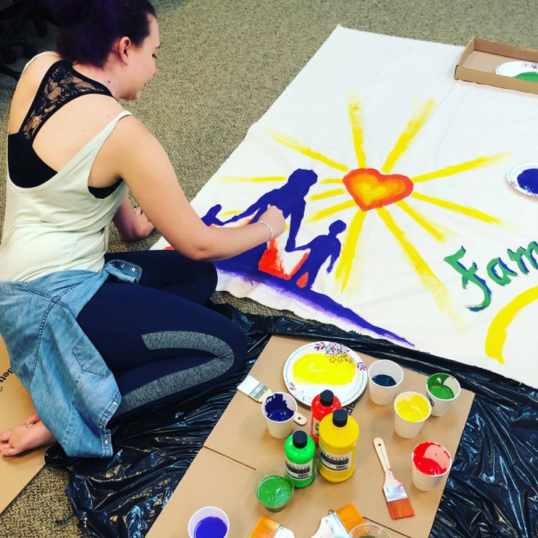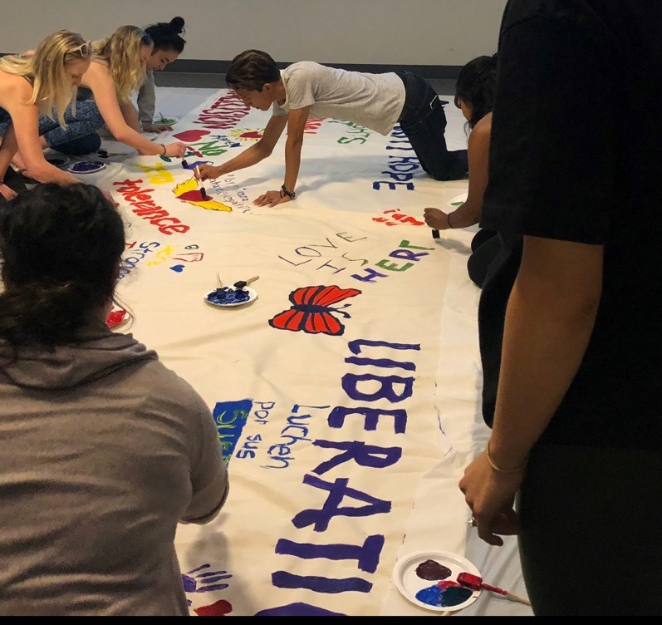
The Delivery Team
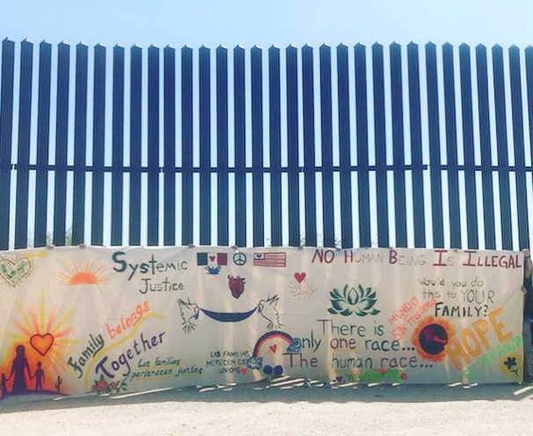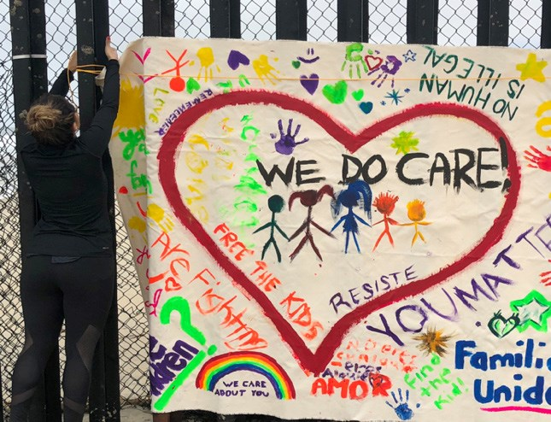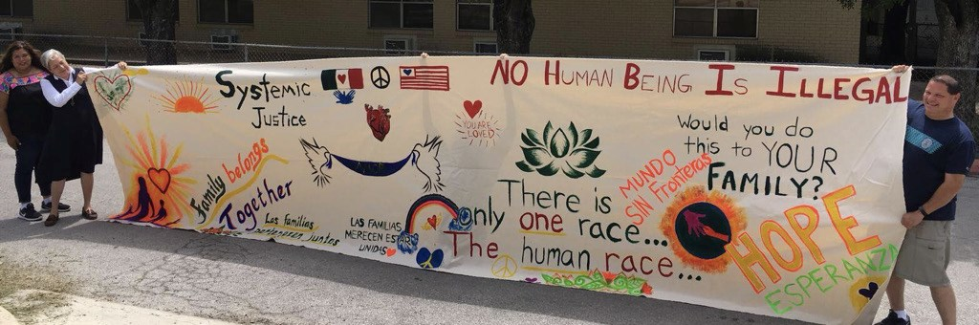
The Message
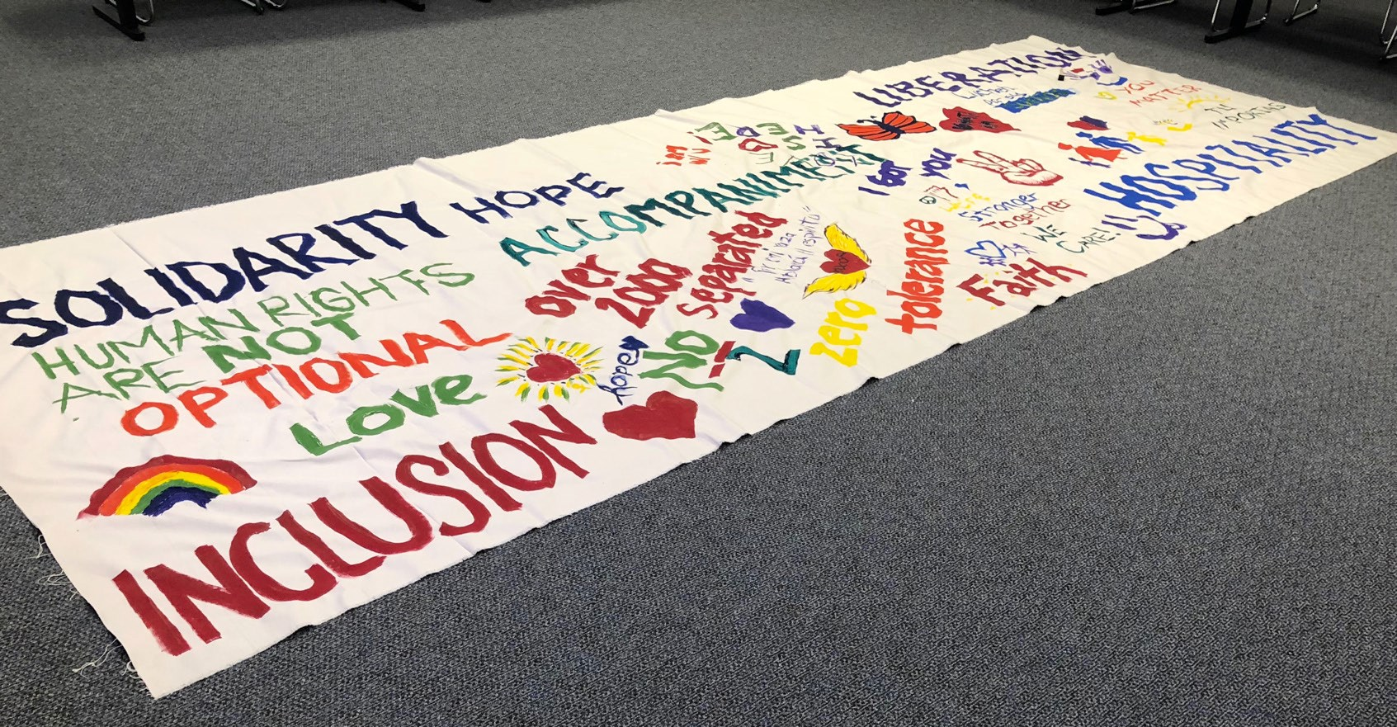

Dr. Daniela Domínguez is a licensed psychologist, licensed clinical counselor, and author of several articles in academic and scientific journals. She has a special interest in social justice concerns, multiculturalism, and immigration issues. Dr. Domínguez provides counseling services to families impacted by President Trump’s ‘zero-tolerance’ immigration policy and she volunteers at a migrant respite center in McAllen, Texas where she engages in crisis intervention.
Vatican Archives, Mother and Teacher, Mater et Magistra # 157, St. John XXXIII, 1961. http://w2.vatican.va/content/john-xxiii/en/encyclicals/ documents/hf_j-xxiii_enc_15051961_mater.html
Manuel Paris et al. Vulnerable but not broken: Psychosocial challenges and resilience pathways among unaccompanied children from Central America. New Haven, CT: Immigration Psychology Working Group, 2018.
“Sharing the Journey,” Kino Border Initiative, accessed on October 1, 2018. https://www.kinoborderinitiative.org/annual-report/
Geneva Sands, “81 Children Separated at Border Since Trump’s Executive Order on Dividing Families,” CNN Politics, https://www.cnn. com/2018/12/06/politics/immigrant-family-separations-children-borderundocumented/index.html
Grandma
H.R. 3396--104th Congress: Defense of Marriage Act. (1996). In GovTrack.us (database of federal legislation). Accessed September 2, 2018, from http://www.govtrack.us/congress/bill.xpd?bill=h104-3396
United States Department of Defense, “Report of the Comprehensive Review of the Issues Associated with a repeal of “Don’t ask, don’t tell,” (2010), https://www.loc.gov/item/2011507489/
Jennifer Chacón, “Immigration and the Bully Pulpit.” Harvard Law Review 130, no. 7 (2017): 243–68. Accessed October 30, 2018. https:// harvardlawreview.org/2017/05/immigration-and-the-bully-pulpit/2.085019146878&site=eds-live&scope=site&custid=s3818721.
Ron Nixon, “Migrant Families Who Enter at Legal Ports Are Rarely Separated, Customs Officials Say,” New York Times, July 9, 2018, https:// www.nytimes.com/2018/07/09/us/politics/customs-border-protectionfamily-separations.html
Rocio Labrador, and Danielle Renwick, “Central America’s Violent Northern Triangle,” last modified June 26, 2018, https://www.cfr.org/ backgrounder/central-americas-violent-northern-triangle.
“Strangers No Longer : Together on the Journey of Hope : A Pastoral Letter Concerning Migration,” Conference of Catholic Bishops, last modified January 22, 2003, http://www.usccb.org/issues-and-action/human-lifeand-dignity/immigration/strangers-no-longer-together-on-the-journey-ofhope.cfm
Daniela Domínguez, “Counseling Psychology Students Working with Mixed- Immigration-Status Families in the Trump Era.” Manuscript under review at the International Journal for School-Based Counseling.
Michael J. Sullivan and Roger Enriquez, “The Impact of Interior Immigration Enforcement on Mixed-Citizenship Families,” Boston College Journal of Law & Social Justice 36, no. 33 (2016): 33-57, http:// lawdigitalcommons.bc.edu/jlsj/vol36/iss1/3
Manuel Paris et al. Vulnerable But not Broken: Psychosocial Challenges and Resilience Pathways Among Unaccompanied Children from Central America. (New Haven: Immigration Psychology Working Group, 2018), 7-100.
Ray Sanchez, Sheena Jones, Dave Alsup and Keith Allen, CNN,“The Chill of Detention: Migrants Describe their Experiences in US custody, July 9, 2018, https://www.cnn.com/2018/07/07/us/separated-families-detentionconditions/index.html
National Public Radio, “What We Know: Family Separation And ‘Zero Tolerance’ at the Border, last modified June 19, 2018, https://www.npr. org/2018/06/19/621065383/what-we-know-family-separation-and-zerotolerance-at-the-border
Lindsey Tanner, “‘Toxic Stress’: How Family Separation May Alter Kids’ Brains,” last modified June 28, 2018, https://www.nbcconnecticut. com/news/national-international/Family-Separation-Affect-KidsBrains-486793591.html
Josie Rhodes Cook, “Psychologists Detail ‘Irreparable Harm’ Done to Separated Immigrant Kids, last modified June 19, 2018, https://www.inverse. com/article/46094-toxic-stress-child-psychology-immigrant-family-separation
Hector Adames, and Nayeli Chavez-Dueñas. Cultural Foundations and Interventions in Latino/a Mental Health: History, Theory, and Within-group Differences (New York: Routledge, 2017).
“Sharing the Journey,” Kino Border Initiative, accessed on October 1, 2018. https://www.kinoborderinitiative.org/annual-report/
John, Pope. “Pacem in Terris.” God and the Moral Order, no. 37 (July 1963). 146–147. doi:10.1080/00396336308440402. http://w2.vatican.va/ content/john-xxiii/en/encyclicals/documents/hf_j-xxiii_enc_11041963_ pacem.html
“Easter 2018 message by Cardinal Luis Antonio Tagle,” Caritas, accessed October 1, 2018. https://www.caritas.org/2018/03/easter-message-bycardinal-luis-antonio-tagle/
“Forming Thoughtful, Committed Citizens,” Conversations on Jesuit Higher Education 51, no. 10 (Spring, 2017), http://www.conversationsmagazine. org/web-features/2017/11/22/forming-thoughtful-committed-citizens
Jesuits, “Jesuits Denounce Unjust Treatment of Asylum Seekers and Migrant Families at the U.S. Southern Border, Last modified June 21, 2018, http://jesuits.org/news-detail?TN=NEWS-20180620041409
Adriana, Siqueira, “The Spirituality of the ‘Spiritual Exercises’ of St. Ignatius,” Thought: Fordham University Quarterly 13, no. 4 (1938): 574– 588. doi:10.5840/thought19381344.

