The SBFC Metamodel

This book is organized around the SBFC Metamodel. The SBFC Metamodel is a trans-disciplinary model for conceptualizing the skills needed for SBFC (see Figure 1.1).

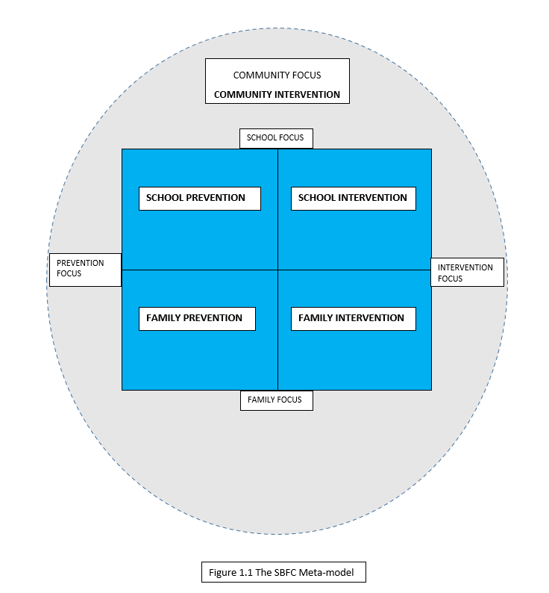

The metamodel is organized around two axes: Family Focus vs. School Focus and Intervention Focus vs. Prevention Focus. The resulting matrix consists of 4 quadrants: School Intervention, School Prevention, Family Intervention, and Family prevention. Community is represented by a dotted line encompassing the family and school quadrants. School Intervention refers to remedial interventions that focus on modifying school environments: parent consultation, teacher consultation, group counseling, crisis intervention, student support groups. School Prevention refers to strategies used to prevent problems from occurring: guidance groups, classroom management, classroom meetings, stress management, anti-bullying programs. Family Intervention refers to remedial interventions that address serious family problems affecting children: parent consultation, conjoint family counseling, family counseling with individuals, couples counseling. Family Prevention refers to psycho-educational strategies to prevent problems from developing in families: parent education workshops, parent support groups. Community Intervention refers to interventions aimed at advocating for children, families and schools through the mobilization of community resources.

